Brandon Bradley

Alana Arjune

Assignment 3

Error Screenshots

var x, y;

begin

x := y + 56;

end

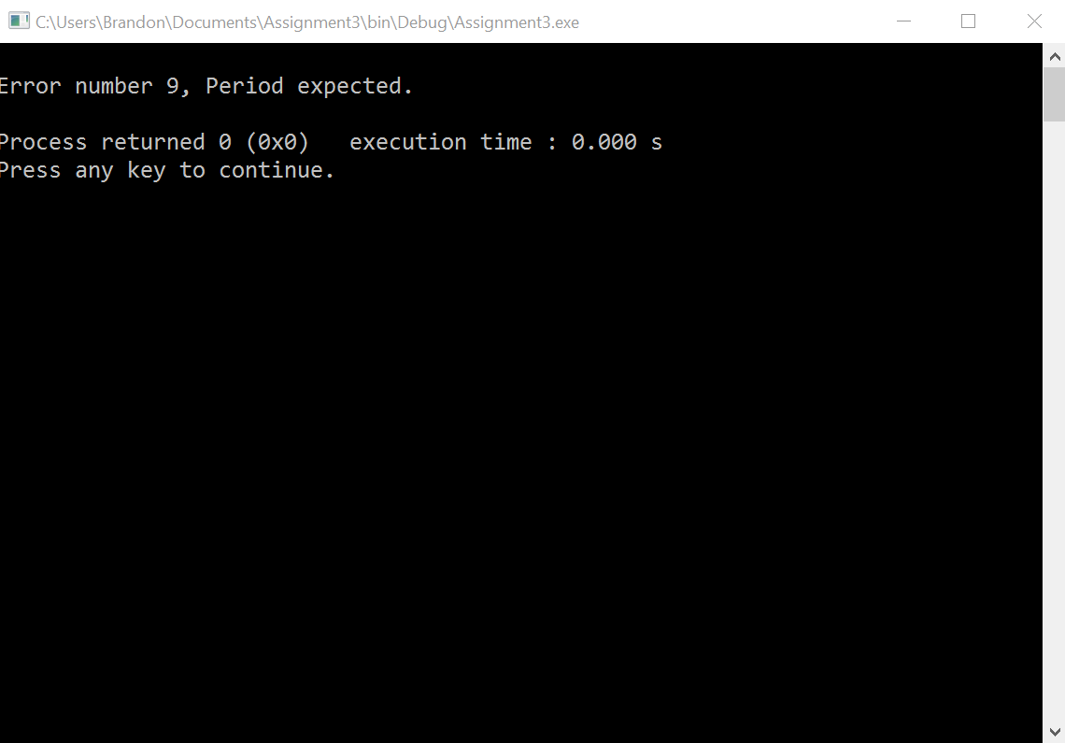

var x, y

begin

x := y + 56;

end.

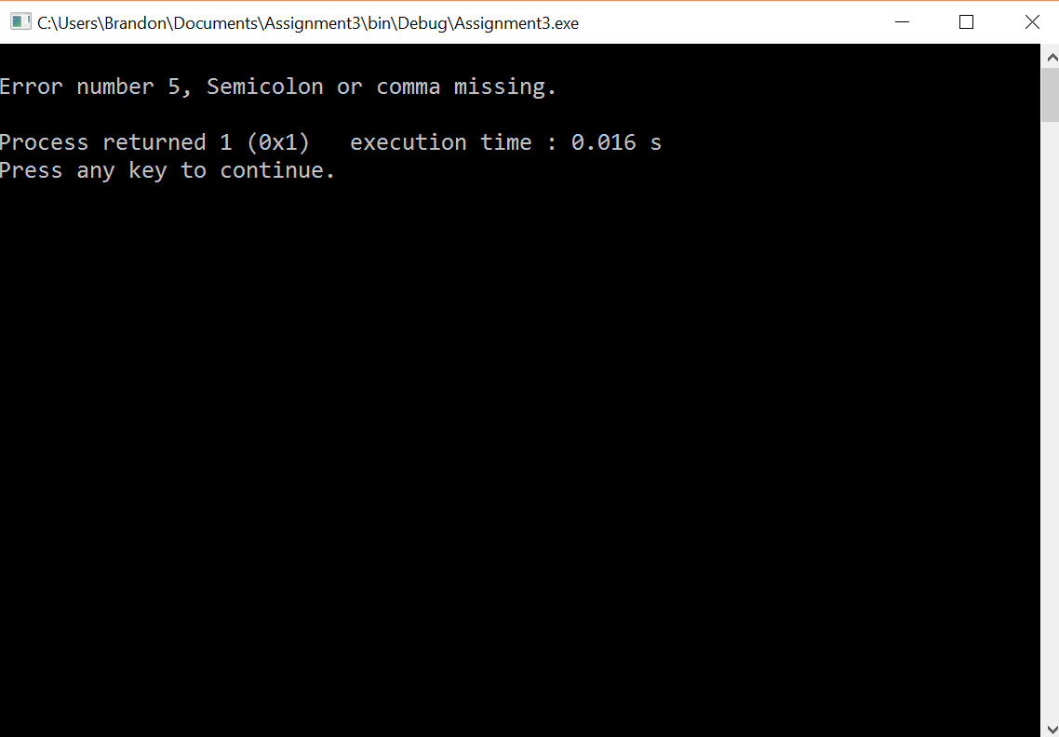

var x, y;

begin x := (y + 56;

end.

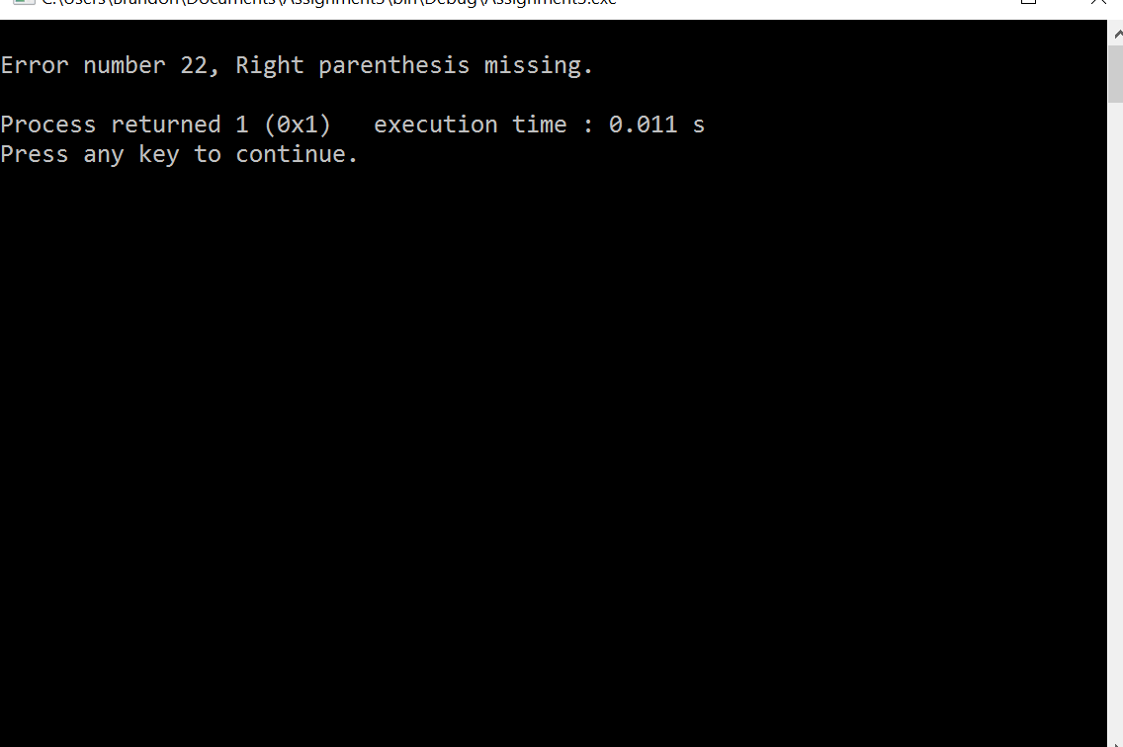

var x, y;

begin x := y + 56);

end.

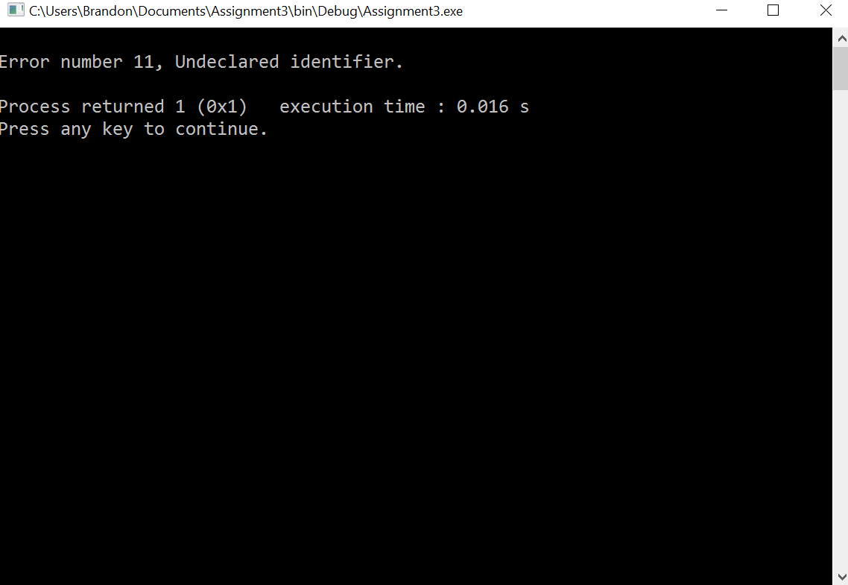

var x, y;

begin x y 56;

end.

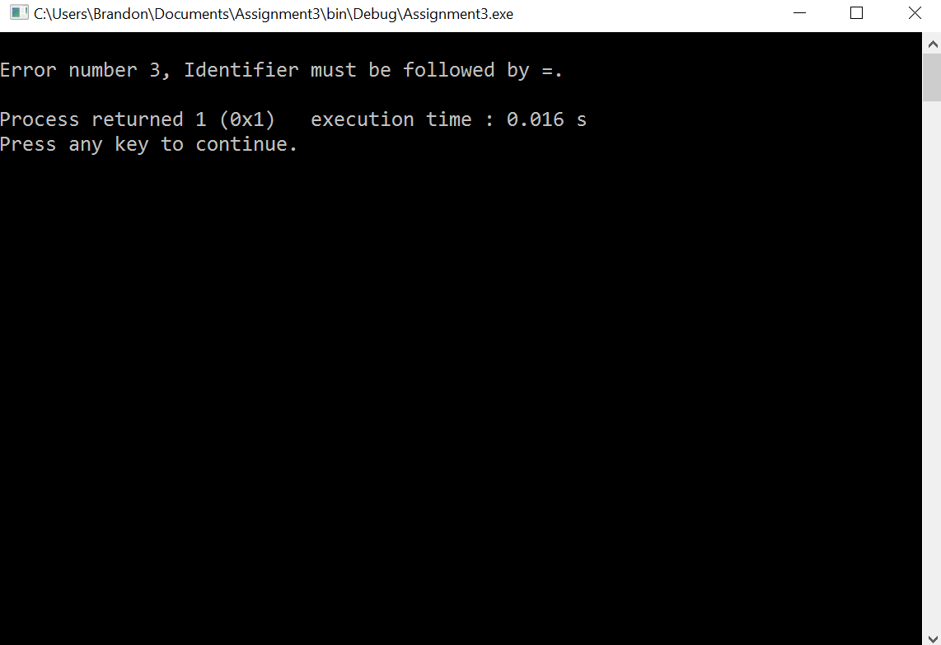

var

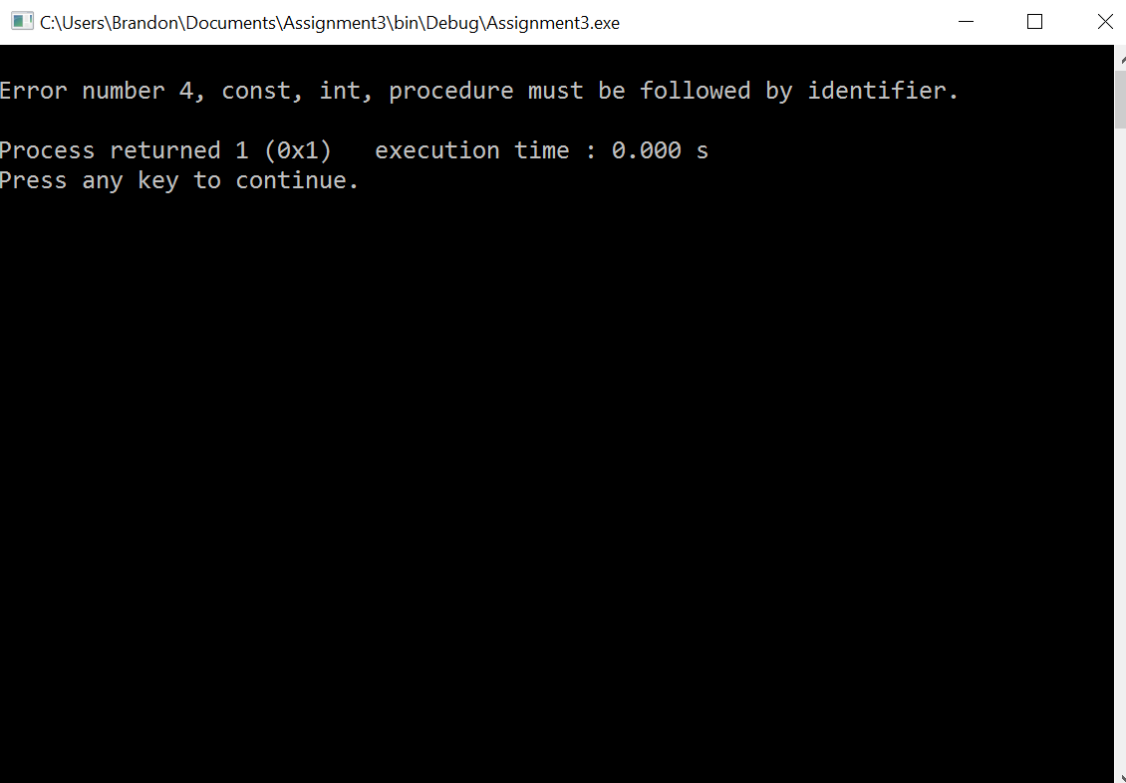

var x y;

begin

end.

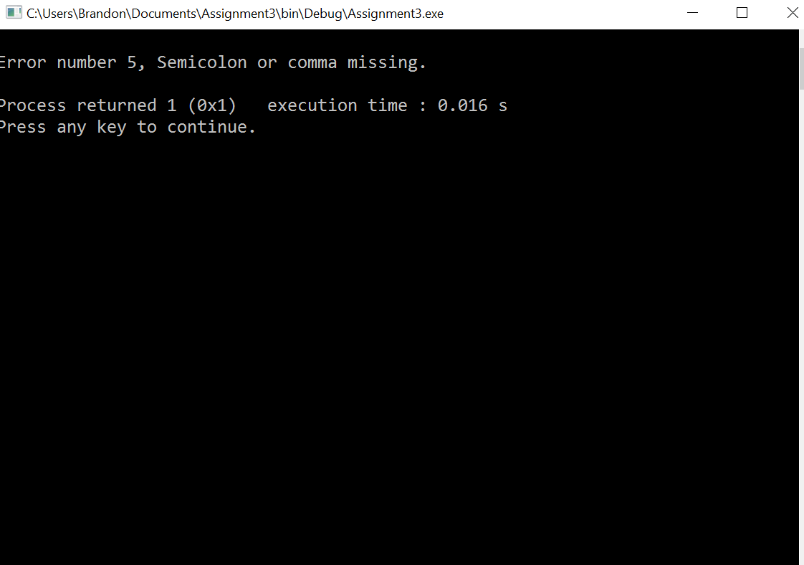

var x,w

begin

x:=4;

end.

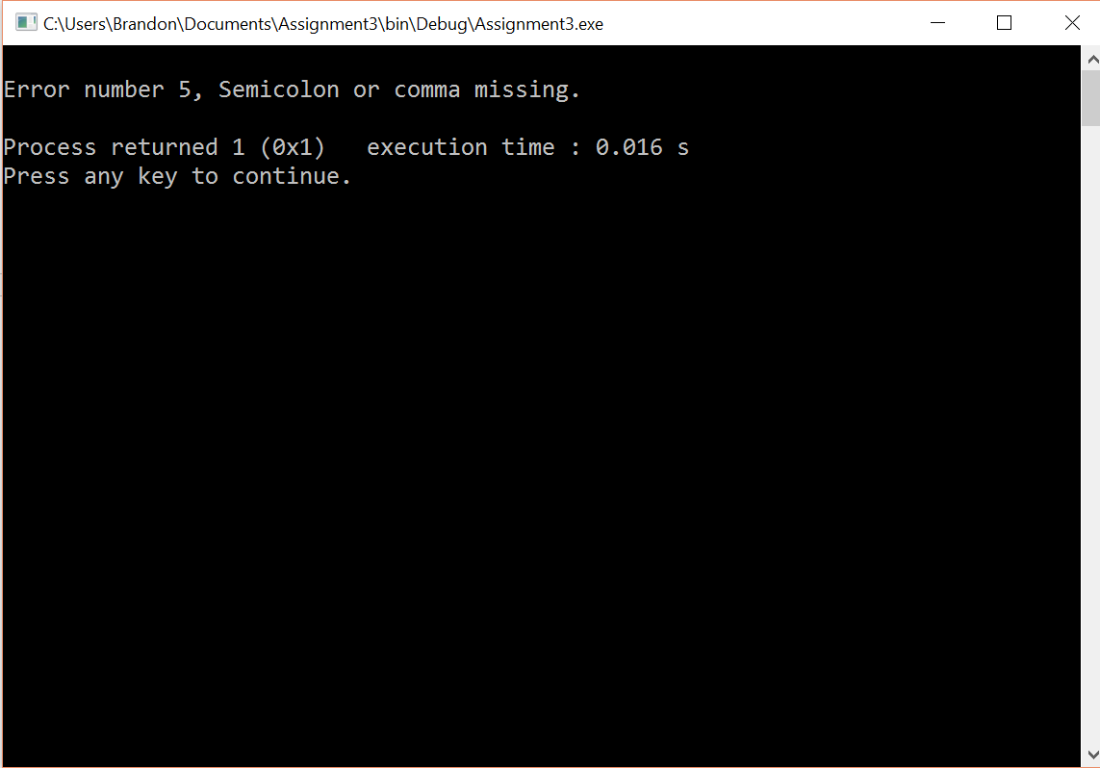

begin

x:=

end.

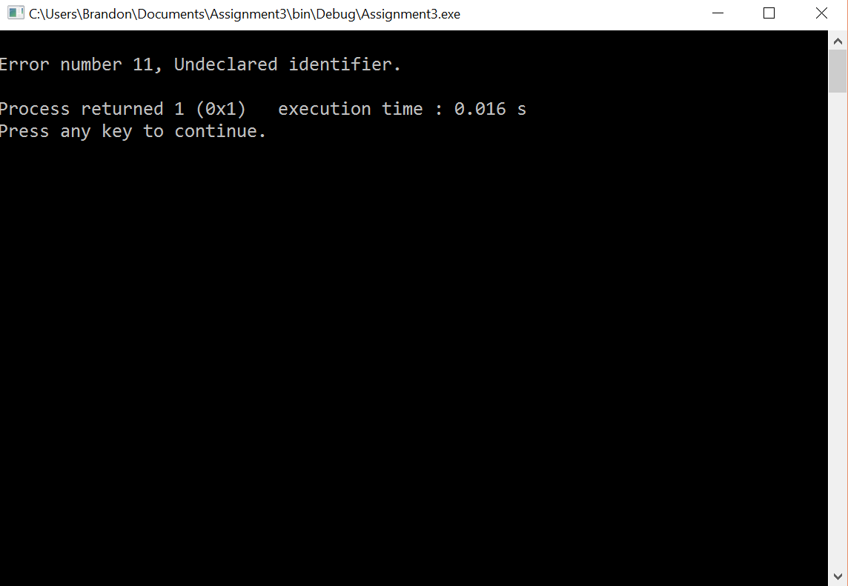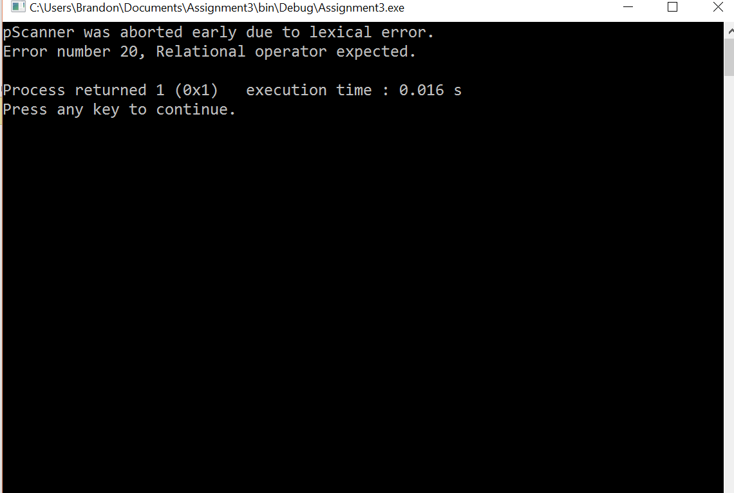

begin

while

x:=3

end.